Progress report

## TungstenPC

Gerard Yu - Team Leader

Deacon Hatwell-Watt - Member

Shawn Peepi - Member

# Contribution

Gerard Yu – Contributed for the stakeholder registry, persona 2, and the group meeting reports.

Deacon Hatwell-Watt – Equal contribution along with other team members for the stakeholder registry, personas, group meeting reports. Created GitHub repository.

Shawn Peepi – Contribution with team members for the stakeholder registry, personas and the group meeting reports.

Our team, TungstenPC, consists of Geronimo Gerard P. Yu IV, Deacon Lars Hatwell-Watt, and Shawn Matu Peepi. We began this project as a collaborative effort, recognizing that each member brings unique strengths and weaknesses. When one member encounters difficulties with a task, the rest of the team steps in to provide support and ensure progress continues smoothly.

One of our initial challenges was completing the stakeholder register, particularly in assigning roles and defining interests within the company. As all members were open to taking on any role, reaching a consensus took some time. However, through discussion and teamwork, we successfully assigned roles that best suited our objectives.

Effective communication has played a crucial role in our success. Utilizing Gmail for correspondence and scheduling meetings during class hours has helped streamline our workflow. Additionally, our GitHub repository has been instrumental in facilitating real-time collaboration, allowing us to track changes efficiently and work cohesively.

By the end of Iteration 1, our team successfully completed the stakeholder register, developed and tested three personas, and finalized a comprehensive meeting report. With these deliverables completed, TungstenPC is confident that we have met all the requirements for this iteration.

As we move forward into Iteration 2, we believe we have a solid understanding of the project requirements. All necessary files for Iteration 1 have been uploaded to our GitHub repository, ensuring an organized foundation for the next phase. This structured approach will guide our team in effectively tackling the upcoming tasks.

# GitHub

<https://github.com/DeaconEIT/TungstenPC>

## Persona 1:

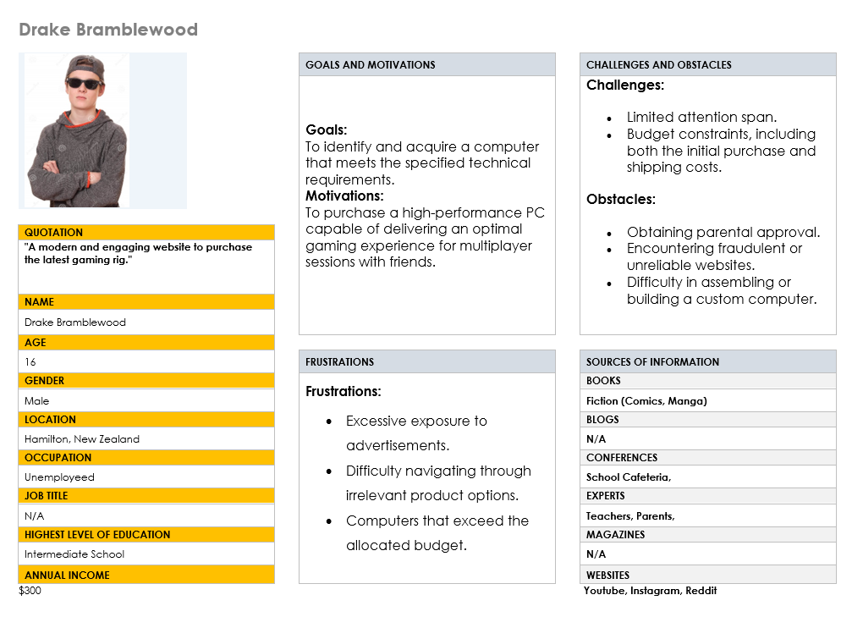

## Persona 2:

## Persona 3: